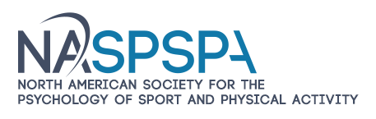

**Promote your business- Exhibit at NASPSPA**

**2025 Annual Meeting of the North American Society for the Psychology of Sport and Physical Activity**

**June 3 to 5, 2025, South Lake Tahoe**

Visit NASPSPA at [www.naspspa.com](http://www.naspspa.com)

Your business has either supported the *North American Society for the Psychology of Sport and Physical Activity* (NASPSPA) in the past or has been identified as one that may have great appeal to our members. We offer a great opportunity for your business to be a sponsor for the NASPSPA program in June of 2025. Being a sponsor will effectively promote your business to NASPSPA members.

NASPSPA is a multidisciplinary association of scholars from the behavioral sciences and related professions. The Society functions to:

* Develop and advance practice through the scientific study of human behavior when individuals are engaged in sport, physical activity, and many other goal-directed pursuits
* Facilitate the dissemination of information
* Improve the quality of research, teaching, and practice in the psychology of sport, motor development, and motor learning and control

We typically have 500 to 600 participants attending our annual meeting. Individuals include many of the top scientists in the fields represented, which includes motor learning and control, motor development, and sport and exercise psychology. NASPSPA also has a strong contingent of students who are looking for graduate programs or careers.

YOU CAN PAY THROUGH PAY PAL USING YOUR BANK ACCOUNT OR CREDIT CARD OR BY CHECK.

Please let me know if you have any questions. Or contact me via email if you are ready to sign up. I will send you the link for payment.

We look forward to working with you to maximize your investment of time and service to our organization.

Penny McCullagh, Ph.D., Executive Director [naspspaed@gmail.com](mailto:naspspaed@gmail.com) 415-225-7754

We thank our 2024 Exhibitors and Sponsors: Auburn University, Louisiana State University, Washington State University, New Mexico State University, University of Florida, Michigan State University, Ohio State University, Rutgers University, Human Kinetics and Wayne State University